**Experiment 9**

**Aim:** To configure and verify Static NAT translation

**Theory:**

Network address translation (NAT) is a method of mapping an IP address space into another by modifying network address information in the IP header of packets while they are in transit across a traffic routing device. The technique was originally used to bypass the need to assign a new address to every host when a network was moved, or when the upstream Internet service provider was replaced, but could not route the networks address space. Create a network topology as shown below in Cisco packet tracer.

**Output:**

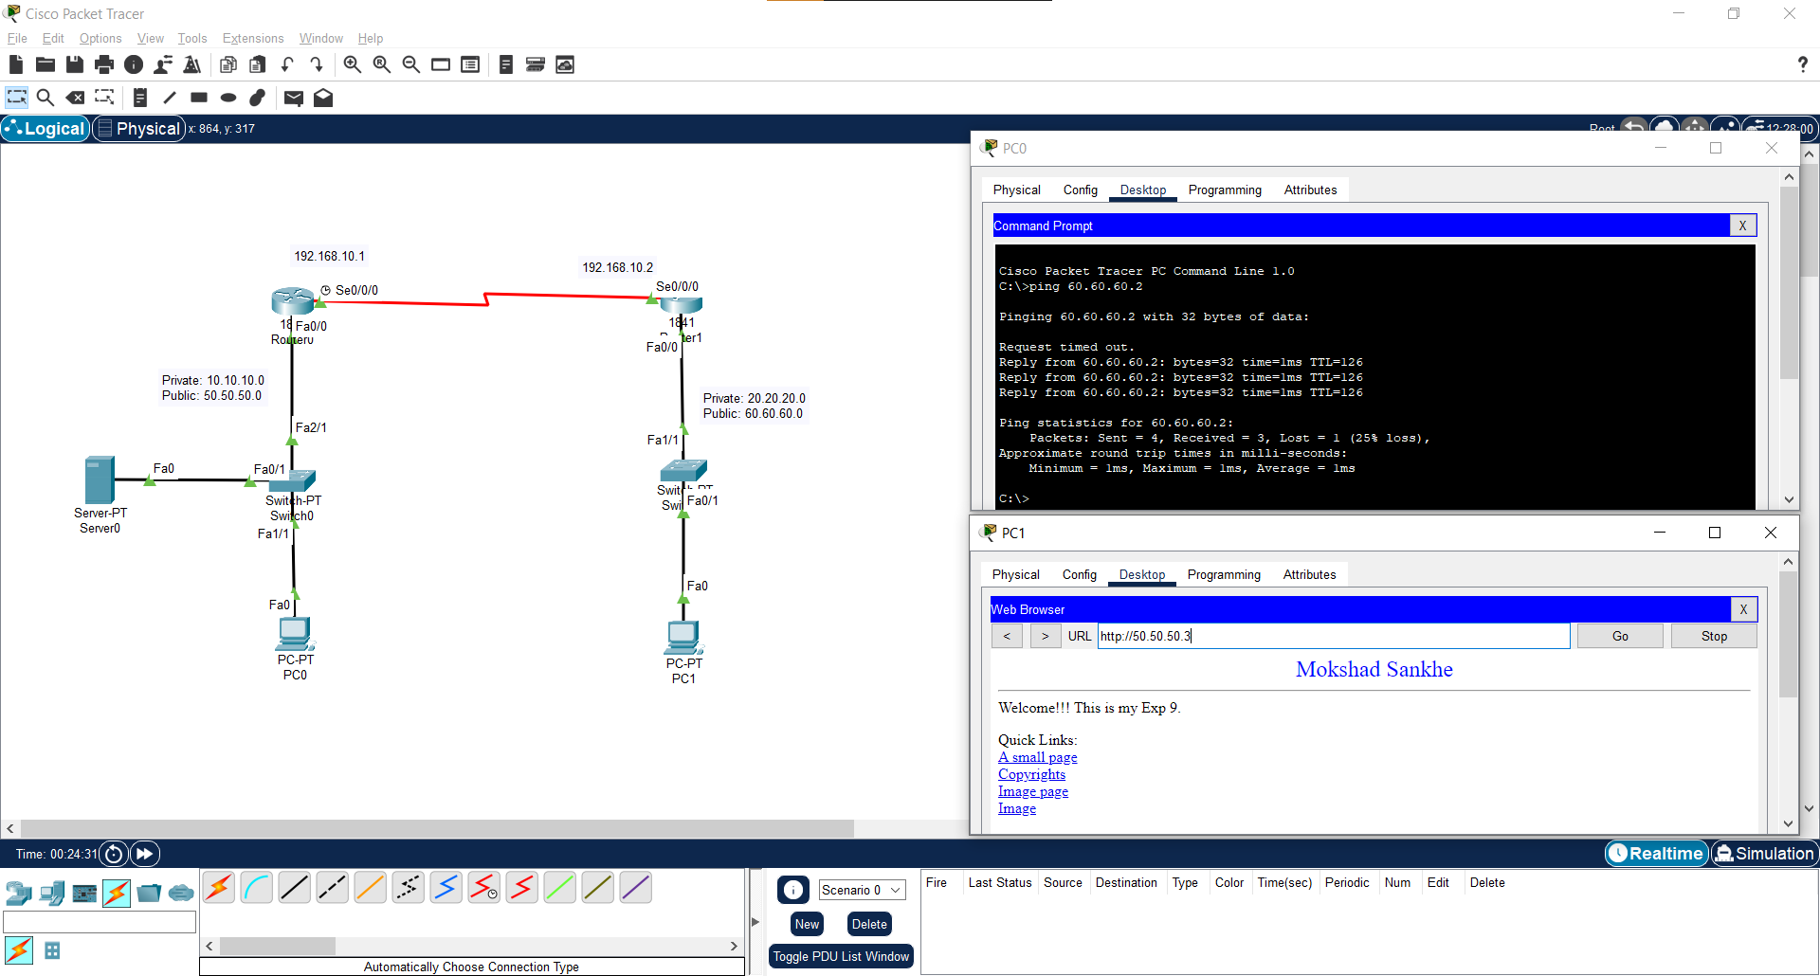**Main:**

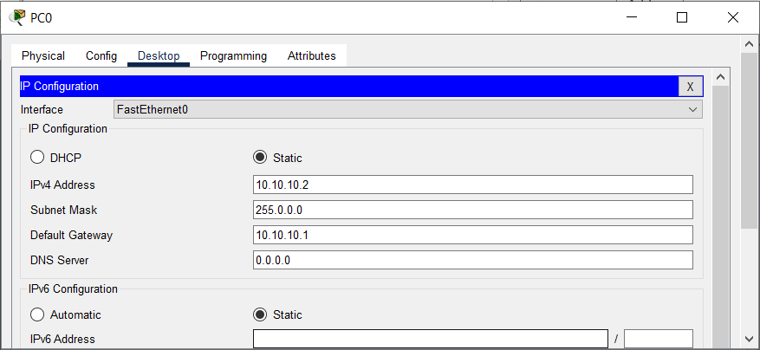**PC IPv4 Configuration:**

**PC1 IPv4 Configuration: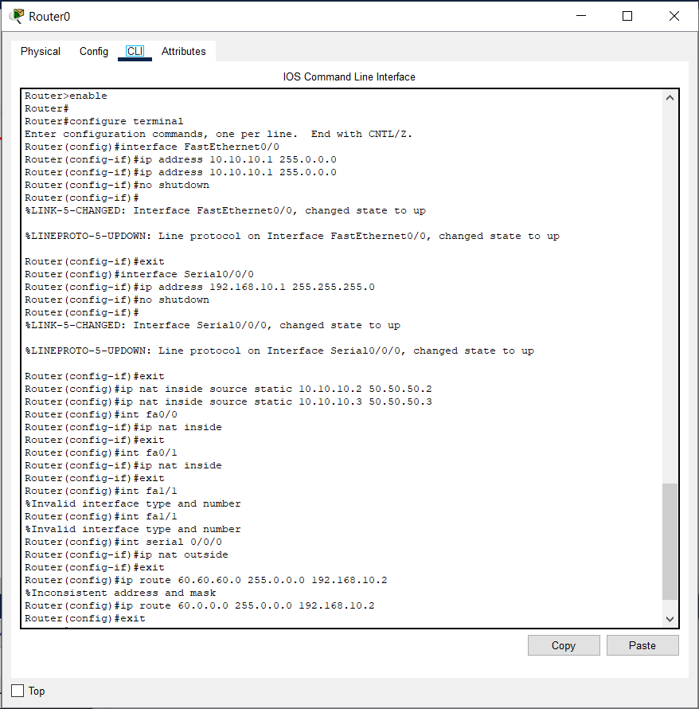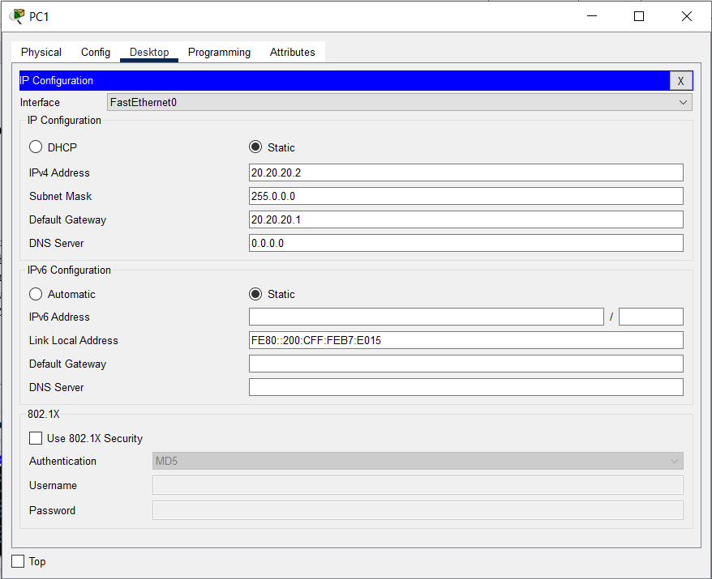Router0 CLI Configuration:**

**Router1 CLI Configuration:**

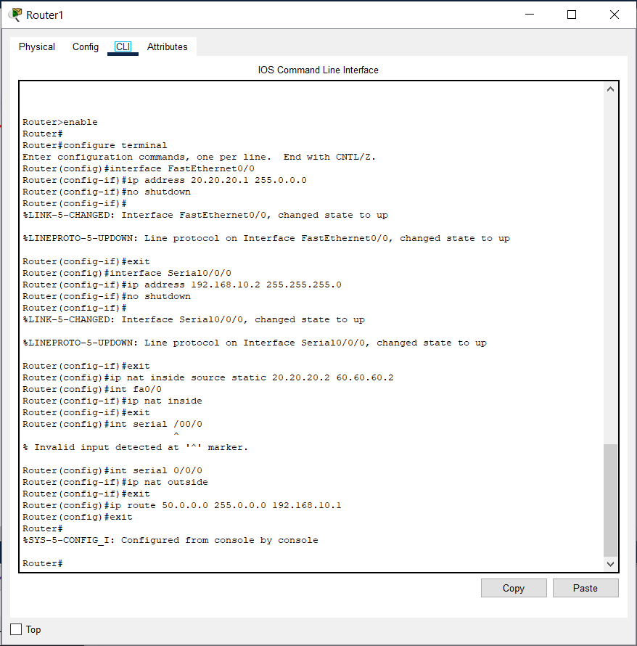

**Server Configuration:**

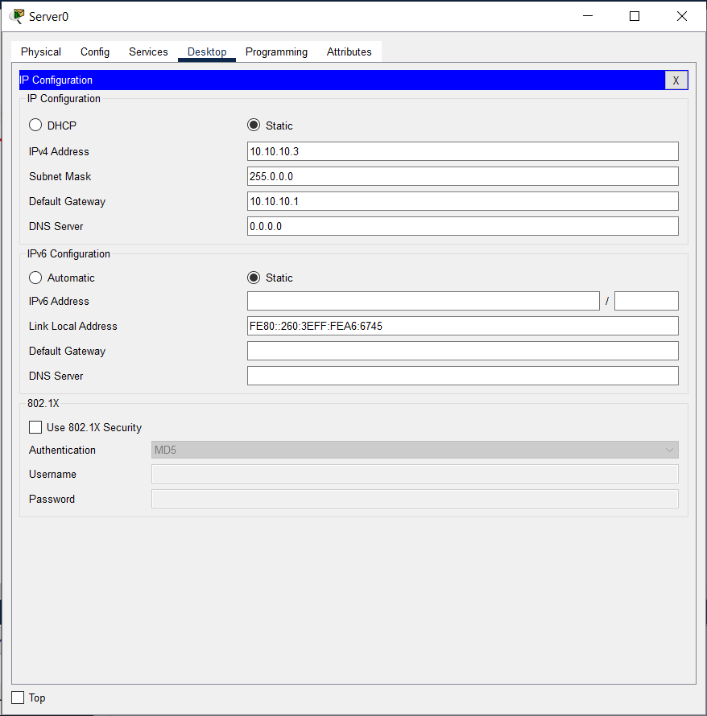

**Server HTTP Service:**

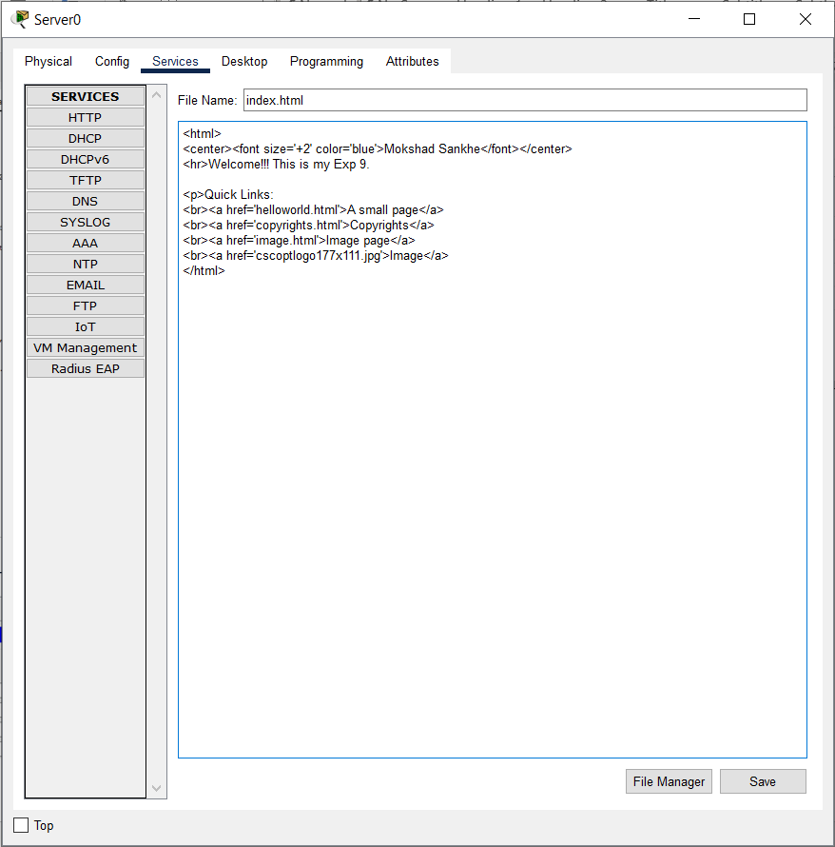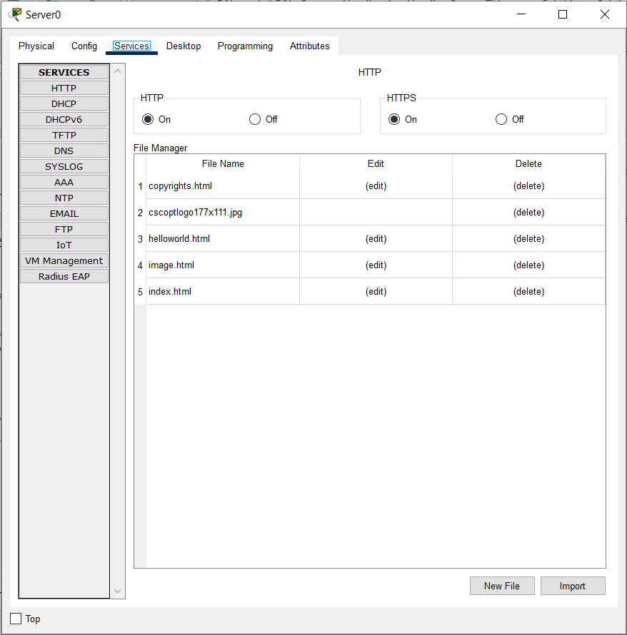

**Conclusion:**